**Deployment for Azure POC**

ARM templates and PowerShell commands are used for deployments.

**3 ARM Templates are created for below components**

* FunctionApp, App service Plan, Sql server.
* Logic App and connection App
* Web App

Used Zip deployment method for the deployment of Azure functions.

**PowerShell Command for deployment**

powershell -f <**FileName**> -subscriptionId **<SubscriptionID>** -resourceGroupName **<ResourceGroup>**

E.g. powershell -f deploy.ps1 -subscriptionId XXXX-XXXX-XXXX-XXXXX -resourceGroupName prospectdeploy

**Files Used in deployment**

* deployment.ps1
* parameters.json
* template.json
* weApp_parameters.json
* webApp_template.json
* logicApp_parameters.json
* logicApp_template.json

**Parameters used in deployment.ps1**

deploy.ps1 is powershell script file which is used to deploy all the components using ARM template. Below are the parameters has been used. Please make sure all the parameters has correct values.

* subscriptionId
* resourceGroupName
* prospectFunctionAppName
* prospectSummaryFunctionAppName
* prospectSummaryFunctionAppAPIUrl
* prospectFunctionAppFilePath
* prospectSummaryFunctionAppFilePath
* clientID
* key
* tenantID

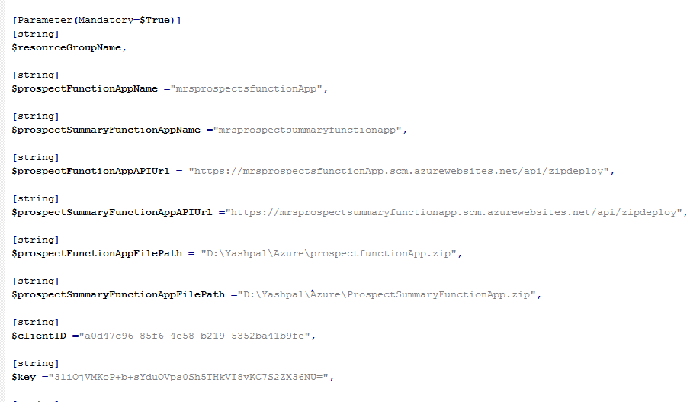

For ClientId, Key and tenantId you need to register app in Azure Active Directory.

Follow steps mentioned in below URL.

<https://docs.microsoft.com/en-us/azure/azure-resource-manager/resource-group-create-service-principal-portal>

**High Level Steps:**

* Register app in Azure Active Directory.
* Generate key.
* Copy ClientId, Key and TenantId and paste it in deployment file.
* Also put replyURL. (<https://mrsmarketSummary.azurewebsites.net/.auth/login/aad/callback>)

Please go through all the parameters and make changes as per your requirement.

Once deployment is done successfully. Please check below configurations/settings. These configurations needs to done for application to work as expected.

**Sql Server**

Make Sure in your database all the tables are created. We have script to create table. Please run that once your database.

**Firewall Settings:**

Go to Sql server and click on show firewall setting.

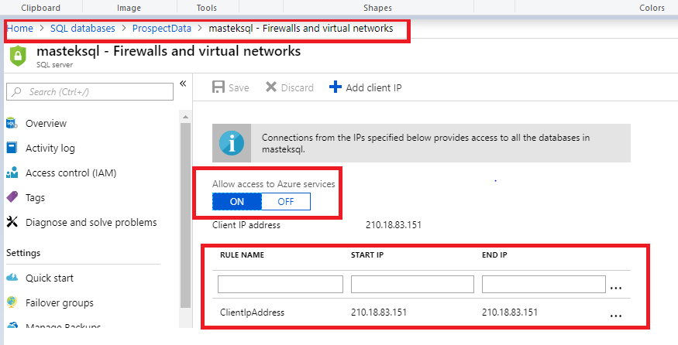

**Web App**

For WebApp check application settings and connection string (Webapp-> Application Settings).

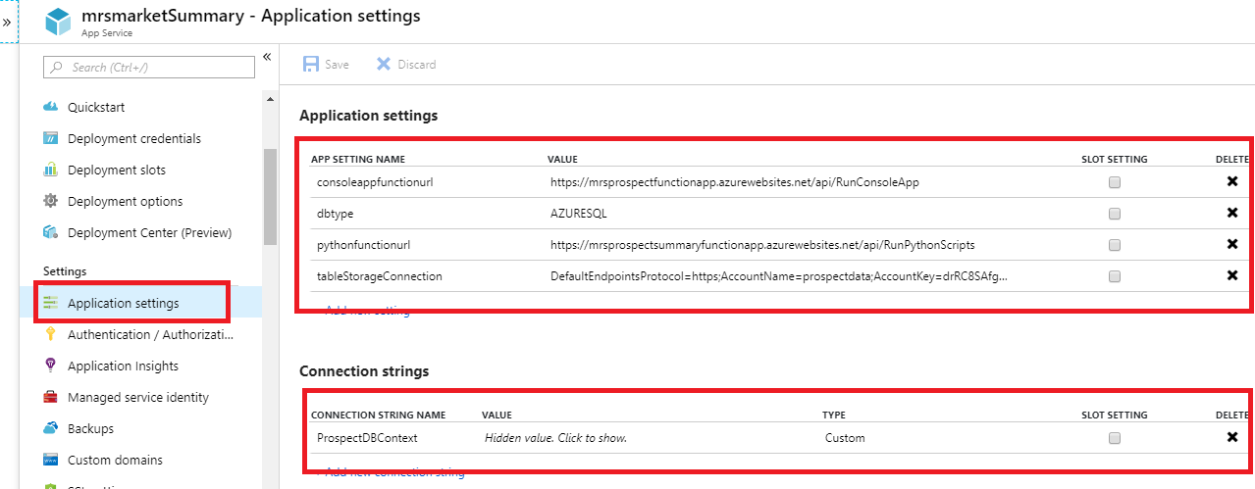

**Authentication/Authorization**

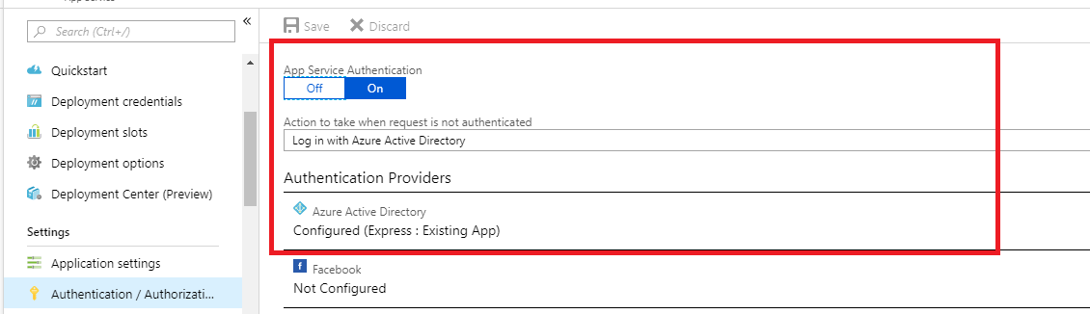

**Azure Function App**

**ProspectFunction – RunConsoleApp:**

In RunConsoleApp, check all the key and values stored in MarketSummaryConsole.exe.Config files.

1. Open RuncosoleApp function present in ProspectFunctionApp.
2. Click on view files tab.
3. Open MarketSummaryConsole.exe.Config and check the values appsettings section and connection string section.
4. Make sure you have correct connection string and Bing search API key.

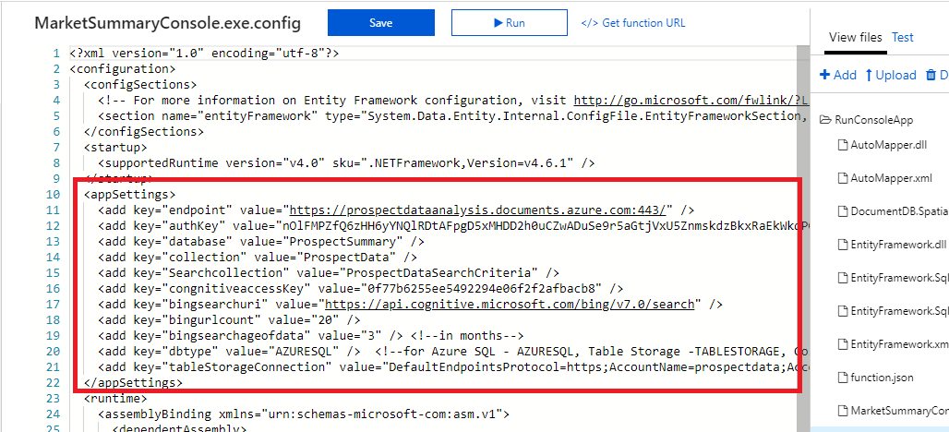

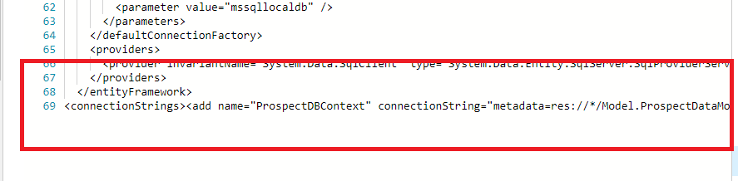**ProspectSummaryFunctionApp /RunPythonScripts**

This function is used to run python scripts. To run python scripts, we need to do setup the python environment. Use below link to setup the python environment for Azure functions.

<http://www.get-vm.com/blog/2018/04/11/python-modules-azure-functions/>

In python scripts, check the credentials (currently hard-coded) used to connect to the SQL database.

Check below 2 files for credentials

1. Run.py
2. URLExtractor.py

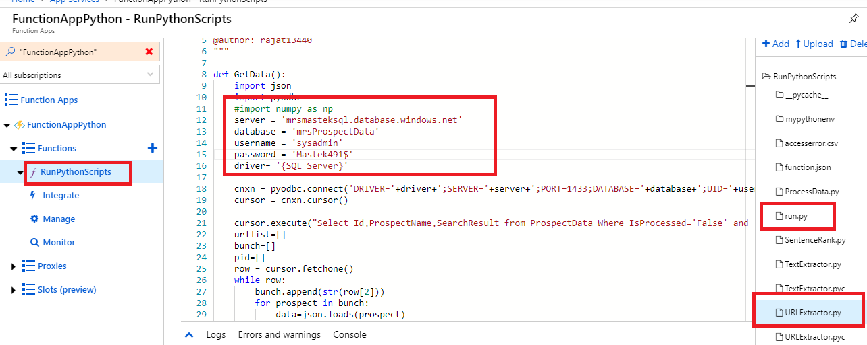

Also check the handler mapping in application settings of functionapp.

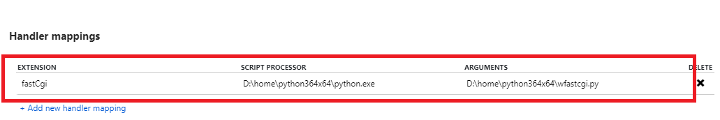

Make sure you have python extension installed.

Go to YourFunctionApp -> Platform features -> Advanced tools (kudu) -> Site extensions

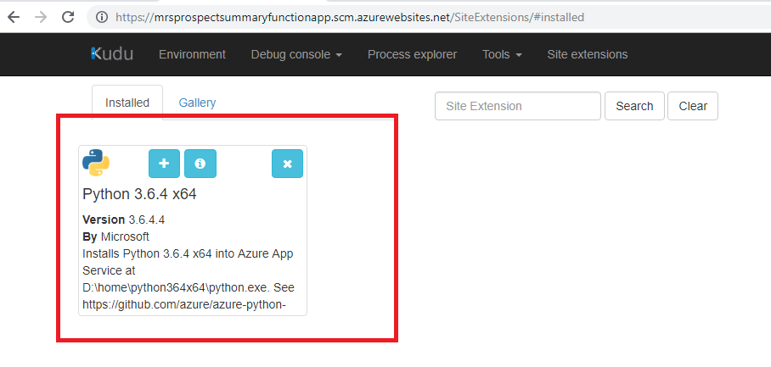

We need to install some of the python packages. Use below commands to install python packages.

Refer below link for how to run python scripts.

<http://www.get-vm.com/blog/2018/04/11/python-modules-azure-functions/>

**Python packages install command**

* pip install bs4
* pip install nltk
* pip install pandas
* pip install pyodbc

**Logic App**

For logic app you need to enter password for gmail configured to make valid connection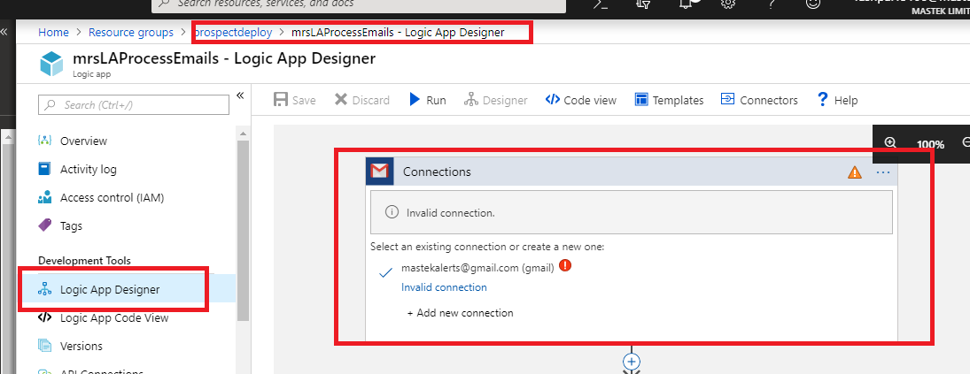

Check whether storage account is properly configured for the Create Blob stage.

